TPS Level III – Section Two

ADULT LEARNING SECTION

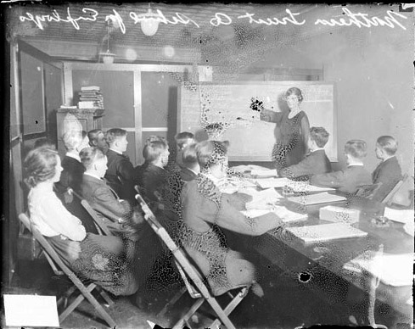

Chicago Daily News, Inc., photographer. Northern Trust Company school for employees.
Date: 1920 Chicago History Museum http://hdl.loc.gov/loc.ndlpcoop/ichicdn.n071673

TPS Program Section Goal:
Participants learn to adapt and deliver TPS professional development and/or create effective coaching relationships that meet the needs of adult learners.

Objectives for Section Two:
As a result of completing the Adult Learning Section, the learner will be able to:

- Describe/discuss core concepts of adult learning theory and how they apply to TPS professional development and coaching.
- Adapt and deliver an effective TPS presentation or activity applying adult learning concepts.
- Evaluate the use of adult learning theory in TPS presentations and professional development

Sample Agenda: Day One

Approximate Time | Topic/Treatment
30 Minutes | 2.1. Program Schedule and Learning Agreements  Staff reviews design, agenda and expectations for TPS Level III Adult Learning section.
30 Minutes | 2.2 Presentation on Characteristics of Adult Learners  Staff builds bridge to presentation and coaching activities by asking participants to note the characteristics of adult learners as opposed to students.
15 Minutes | 2.3. Adult Learner Warm-Up Exercise  Participants share stories about their “best” and worst” professional development experiences in small groups followed by large group processing and discussion.
45 Minutes | 2.4. Adult Learning Considerations  Participants consider various adult learning theories and apply them each theory to TPS coaching situations.
15 Minutes | Break
60 Minutes | 2.5. Communication/Relationship Styles Examination  Participants score the communications style inventory that they completed as homework. Staff leads discussion on style and how it impacts communications and the mentoring relationship. Concludes session by developing communication “map” for the participant group and assessing its implications.
 | 2.6. TPS Program Section Reflection  Participants complete program reflection.
  15 Minutes | 1.18 TPS Program Section Reflection  Participants complete program evaluation.

NOTES TO FACILITATOR:

Power Point Slides

- Slides are used in various activities throughout this and other sections of the Level III curriculum. All of these slides are available via the TPS Teacher’s Network and can be downloaded. These slides should be reviewed prior to implementation.

Professional Development Logistics

- Equipment/Material Requirements: The requirements for each activity are specified on the activity. The general requirements are: LED projector, screen, flip chart, easels and power strips to accommodate 12-16 participants using their laptops throughout the program. Sample Room Set Up:

- Room Requirements: The participants will work in breakout groups at several points. Therefore, there should be sufficient space for movement during the session. A room of 900 square feet or more is recommended to accommodate 16 participants and 2-4 facilitators.

- Room Layout: The ideal set-up for the room is a U-shape with a screen at the front of the U and two easel stands with flip chart paper on either side of the screen.

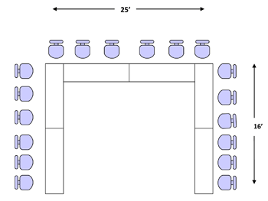

Projector

Presenter Table
Flip Charts

2.1. Program Schedule and Learning Agreements
30 Minutes

Goal

To orient participants to nature and structure of the TPS Level III program and to get a commitment from participants to collaborate in sharing ownership for achieving program learning goals and objectives.

Objectives for this section

Participants will:

- Understand and be able to explain program intent and design;
- Review training objectives and agenda;
- Describe their expected learning objectives and outcomes;
- Share learning goals for reference and follow-up.

Core Competencies

Not applicable to this activity

Materials

- TPS Level III program slides
- Projector
- Flip chart easel
- Flip chart pad
- Felt tip markers/Masking tape
- Participant’s Workbook

Preparation

- Develop personal comments on importance of sharing personal knowledge, information, insights and experience as part of the adult learning process.

Procedure

- Explain that this segment of agenda is intended to establish a common understanding of the framework and process for accomplishing program purpose.

- Review the TPS Workshop Objectives.

- Review the TPS Program Section Agenda. Describe each component of Day One of Agenda.

Ask for any questions on the TPS Program Section objectives and agenda and respond to them.

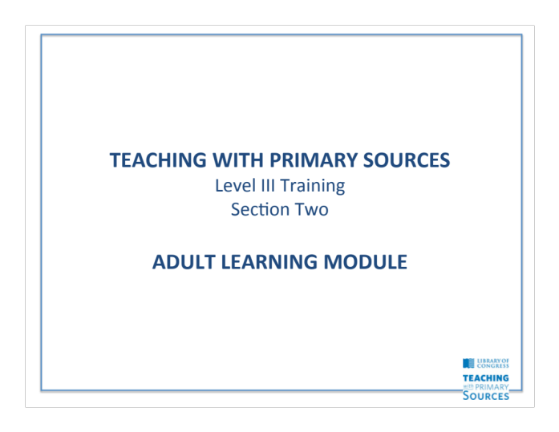

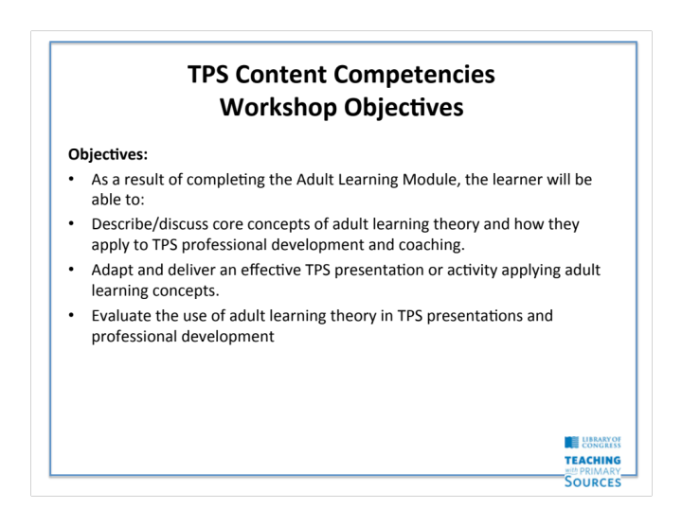

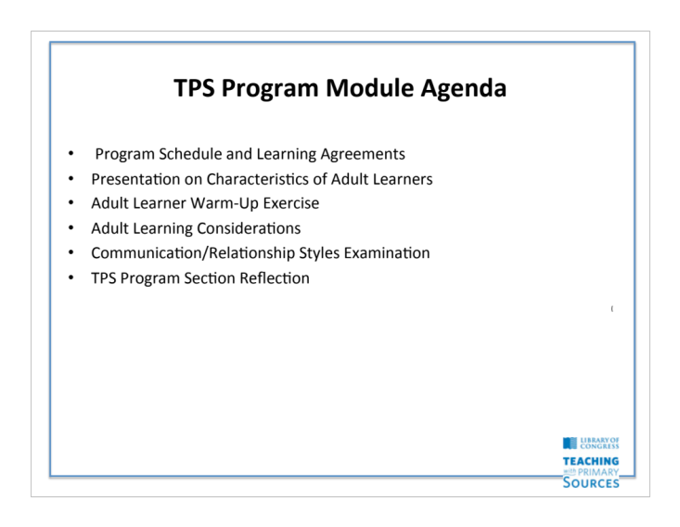

2.2. Presentation on Characteristics of Adult Learners
30 Minutes

Goal

To remind participants of nature and structure of the TPS Level III program, to orient them to the structure of this activity, and to secure continuing buy in and personal contracting from participants to collaborate in sharing ownership for achieving program learning goals and objectives.

Objectives for this section

Participants will:
- Understand and be able to explain the intent and design for the TPS Level III program.
- Describe their learning objectives and outcomes for this activity.
- Share learning goals for reference and follow-up.

Materials

- Worksheet 4.2
- Digital projector
- Flip chart easel
- Flip chart pad
- Markers/Masking tape
- Felt tip pens

Preparation

- Review overview section of and Facilitator’s Guide to ensure complete understanding of program instructional system design.
- Refine personal comments on importance of sharing personal knowledge, information, insights and experience as demonstrated by participants during previous activities.

Procedure

- Review the TPS Level III core competencies.

- Review Agenda. Ask for any questions.

- Refer participants to learning objectives for this Section and ask them to add their personal learning goals and complete the “Resources I Bring” worksheet.

- Ask participants to share personal goals for this workshop. Record answers on flip chart pads on separate easels – “Personal Goals” and “Resources I Bring.”

- Ask for any questions or comments before moving into the content.

- Tear off flip chart pages and post them next to other flip chart pages.

Worksheet 4.2: Self-Assessment

This section focuses on building your knowledge, skills and abilities in the Professional Development and Coaching areas:
- Adult Learning Theory
- Presentation Skills
- Group Facilitation
- Coaching
- Communications

Review and consider the competencies and behavioral objectives for this section. Then, complete the worksheet below noting your Professional Development and Coaching experience and resources that you bring to this training. These resources and goals will be shared, reviewed and added to as you work with the other learners and facilitators throughout the course of this Section.

Resources I Bring | Learning Goals

2.3 Adult Learner Warm-Up Exercise
15 minutes

Goal
To focus the participants attention on the central importance that treating adult learners as adult learners plays in delivering effective professional development experiences.

Objectives for this section
Participants will:
- Identify personal “bad” and “good” professional development experiences;
- Define the characteristics of a “good” experience for the adult learner.

Core Competencies

Adult Learning Theory
- Identify the core concepts of adult learning theory.

Materials

- Flip chart pages

Preparation

- Develop opening and closing comments.
- Prepare own “best” or “worst” professional development experience to share with group.

Procedure

- State that to start this section we want to think about what makes for good and bad professional development experiences.

- Have each participant write down their best and worst professional development experiences and explain why they believe these approaches to be effective or ineffective.

- Break the participants into small groups of three or four and have them share their best and worst experiences and pick one or each to report out to large group.

- Lead report out and record responses “Best Professional Development Experiences” on one flip chart pad and “Worst Professional Development Experiences” on a second flip chart pad.

- After all best and worst experiences have been listed, ask participants to identify themes for what makes for good professional development as opposed to what makes for bad professional development. Note themes on flip chart page.

- Piggy back on their answers and ensure to make point that part of success in professional development is to ensure that adult learners are made to feel and be part of the professional development process.

- Post flip charts on the wall.

2.4 Adult Learning Considerations
60 minutes

Goal
While we are all adult learners, to understand the practical considerations of adult learning, this section will focus on a variety of adult learning theories to aid participants in designing and delivering training materials for teachers and administrators.

Objectives for this section
Participants will:
- Review the Practical Applications of each Adult Learning Theory;
- Discuss how to apply each theory in their role as TPS coaches.

Core Competencies

Adult Learning Theory
- Identify the core concepts of adult learning theory.

Materials

- Flip chart pages

Preparation

- Review material presented below,

Procedure

- State that to start this section we want to think look at different theories about adult learning and apply those theories to their work as TPS presenters and coaches.

- Display and review the slide reviewing the Practical Applications of the following Adult Learning Theories:
  - Pedagogical Theory
  - Andragogy Theory
  - Transformative Theory
  - Self-Directed Learning

- State the group will now review the practical applications of the four adult learning theories just discussed. Tell participants they should use this exercise to think about how they might implement these applications as a TPS coach.

- Complete the following activity: Creating a Critical Incident tool of Effective TPS Coaching Behaviors

- Break up into groups of three.

- Have each group member describe (by writing down on piece of paper) four individual incidents (i.e., observable human behaviors) that illustrate specific ways in which a TPS coach might apply one of the adult theory applications to a TPS coaching context.

- Give the following example:

  - A 6th grade social studies teacher comes to a TPS coach asking for prints and sound recordings of the Civil War. The TPS coach assesses the social studies teacher as an intermediate self-director and provides the teacher with the link to the Teacher Resources from the Library of Congress website that focuses on the Civil War.
  - Remind groups that at the end of this step, each group should have at least 12 different critical incidents, that is, 12 separate sheets of paper.

- As a group, decide which incident is the most effective to the least.

- Tape each incident to the wall by taping the most effective incident on top and the least effective incident on the bottom to create a continuum.

  - Note: At the end of this step, the group should have created a 12 point continuum from most effective incident to least

- Review the following points with participants:
  - Adults learn differently than children.
  - When designing a coaching curriculum, coaches want to implement effective adult learning theories and practical applications.
  - While no one theory explains how adults learn nor do they provide practical applications for all contexts, the four theories presented in this lesson offer a variety of techniques.
  - Coaches need to decide which practical applications are suitable for their participants’ needs, wants, and abilities.
  - Coaches can also use your critical incident tool to aid you in determining what coaching behaviors are more effective than others.

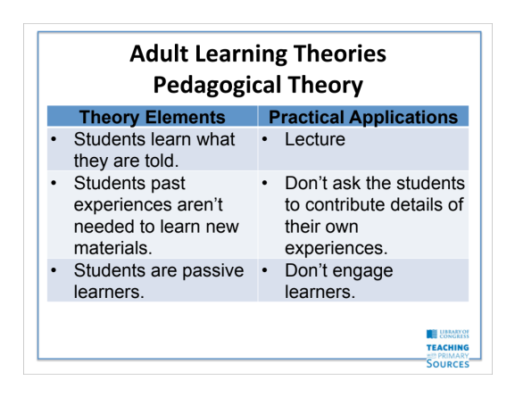

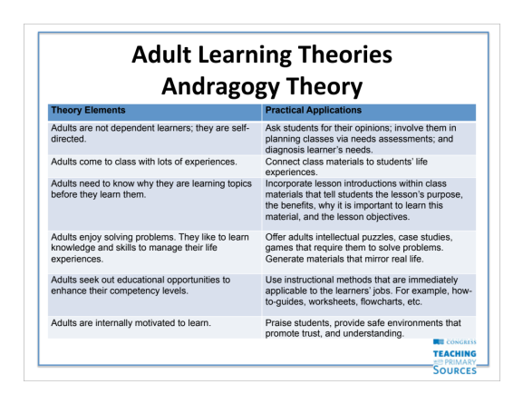

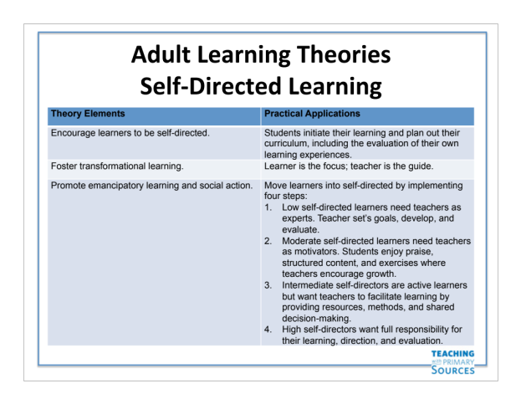

Adult Learning Theories

Pedagogical Theory
Theory Elements | Practical Applications
Students learn what they are told. | Lecture
Students past experiences aren’t needed to learn new materials. | Don’t ask the students to contribute details of their own experiences.
Students are passive learners. | Don’t engage learners.

Andragogy Theory
Theory Elements | Practical Applications
Adults are not dependent learners; they are self-directed. | Ask students for their opinions; involve them in planning classes via needs assessments; and diagnosis learner’s needs.
Adults come to class with lots of experiences. | Connect class materials to students’ life experiences.
Adults need to know why they are learning topics before they learn them. | Incorporate lesson introductions within class materials that tell students the lesson’s purpose, the benefits, why it is important to learn this material, and the lesson objectives.
Adults enjoy solving problems. They like to learn knowledge and skills to manage their life experiences. | Offer adults intellectual puzzles, case studies, games that require them to solve problems. Generate materials that mirror real life.
Adults seek out educational opportunities to enhance their competency levels. | Use instructional methods that are immediately applicable to the learners’ jobs. For example, how-to-guides, worksheets, flowcharts, etc.
Adults are internally motivated to learn. | Praise students, provide safe environments that promote trust, and understanding.

Transformative Learning
Theory Elements | Practical Applications
Alters students’ consciousness in dramatic and enduring ways that lead to integrative perspectives. | Activities that encourage critical reflections, thoughtful discussions, and student-experiences.

Self-Directed Learning
Theory Elements | Practical Applications
Encourage learners to be self-directed. | Students initiate their learning and plan out their curriculum, including the evaluation of their own learning experiences.
Foster transformational learning. | Learner is the focus; teacher is the guide.
Promote emancipatory learning and social action. | Move learners into self-directed by implementing four steps:  - Low self-directed learners need teachers as experts. Teacher set’s goals, develop, and evaluate.  - Moderate self-directed learners need teachers as motivators. Students enjoy praise, structured content, and exercises where teachers encourage growth.  - Intermediate self-directors are active learners but want teachers to facilitate learning by providing resources, methods, and shared decision-making.  - High self-directors want full responsibility for their learning, direction, and evaluation.

references

Baumgartner, L. M.; Lee, M.; Birden, S; Flowers, D. (2003). Adult learning theory: A primer. Washington, DC: Office of Educational Research and Improvement.

Hodge, S. (2011). Learning to manage: Transformative outcomes of competency-based training. Australian Journal of Adult Learning, 51(3), 498 – 517.

Kenner, C. & Weinerman, J. (2011). Adult learning theory: Applications to non-traditional college
students. Journal of College Reading and Learning, 41(2), 87-96.

McGrath, V. (2009). Reviewing the evidence on how adult students learn: An examination of Knowles’ model of andragogy. The Irish Journal of Adult and Community Education, 99-110.

Merriam, S. B. (2008). Adult learning theory for the twenty-first century. New Directions for Adult and Continuing Education, 119, 93 – 98.

Oddi, L. F. (1986). Development and validation of an instrument to identify self-directed continuing learners. Adult Education Quarterly, 36(2), 97-107.

Yang, B. (2004, March). A critical evaluation of adult learning theories and implication for human resource development. Paper presented at the Academy of Human Resource Development International Conference in Austin, Texas, 842-849.

2.5. Communication/Relationship Styles Examination
60 minutes

Goal

To enable the participant to analyze their own communications style and to identify the impact that style has on communications interactions and steps that can be taken to communicate effectively with others with different styles.

Objectives for this section

Participants will:
- Review and discuss the four major communicating/relationship styles and the impact they have on the quality of communications.
- Identify and examine their own preferred or dominant styles.
- Identify and examine their least preferred styles.
- Examine their communicating styles under “favorable” and “stress” conditions.
- Review and discuss the implications of communicating style in terms of training, mentoring and coaching on TPS.

Core Competencies

Communications
- Identify the four major communications/relationship styles.
- Identify own style preference and actions that can be taken to improve communications with those of differing styles.

Coaching
- Assess coaching capabilities and develop an improvement plan.

Materials

- Communicating Styles Surveys from Training Associates Press (1 each)
- Interpretation Manual for CSS
- Communicating Styles Slides
- Communication Map of Participants under Normal Conditions
- Communication Map of Participants under Stress Conditions
- Flip chart pads
- Flip chart easel stands
- Slide projector
- Overhead projector

Preparation

- Take and score the Communicating Styles Survey and interpret it using the Interpretation Manual for CSS.
- Review the Interpretation Manual in detail to understand communicating styles theory and practice.
- Review the communications and relationship style information in the Participant’s Workbook.
- Review the communications style procedures and slides and rehearse make personal notes on points that you want to make in presenting this material.
- Ensure that all participants have completed surveys before starting activity.

Procedure

Activity Set-Up

- Have the participants open their Communicating Styles Survey and tear the answer sheet away from the survey booklet. Read through the scoring instructions and then have the participants score their surveys following the instructions.

- Circulate to ensure that all participants are scoring survey appropriately.

- When all participants have completed their scoring begin the presentation.

Presentation/Discussion

- Begin by stating that there are four major communicating styles:
  - Intuitor: Conceiving, projecting, future oriented
  - Thinker: Analyzing, ordering, fact oriented
  - Feeler: Relating and responding to emotions
  - Sensor: Relating and responding to events

- Note that we have all four styles but each of us have a primary and a secondary style that is preferred. Provide examples of occupations with preferred or dominant styles (SL 4.23.b)
- Intuitor: Scientists, Artists
- Thinker: Accountant, Engineer
- Feeler: Teachers, Nurses
- Sensor: Sales Persons

- Ask the participants to guess the dominant styles of American Presidents
- Carter – Thinker/Feeler
- Kennedy – Intuitor
- LBJ – Sensor
- Reagan – Feeler
- Bush Sr. – Feeler
- Clinton – Intuitor (All 4)
- George W. Bush – Sensor
- Obama – Thinker

- Say that our styles have an impact on who we work or communicate well with and whom we have difficulty relating to:
- It’s easiest to relate to people who have the same dominant style
as our own.
- Intuitors get along best with feelers and thinkers get along best with
sensors.
- Thinkers and feelers are polar opposites as are intuitors and
reactors.

- Say that communicating styles have both good and bad features or characteristics and review a few for each on overhead.

- Ask if participants have any general questions before going into an analysis of their scores on the survey questionnaire.

Analyzing the Survey Responses

- Instruct the participants to look back at their scores and to compare the spread between their primary and secondary style. Note that a seven plus spread indicates a clearly greater reliance on the dominant style.

- Instruct the participants to look at their FC (Favorable Conditions) scores and compare them to their SC (Stress Conditions) scores and to note the shift.

- Have the participants call out their primary scores under Favorable Conditions and plot them on the Communicating Styles Map – Normal Conditions. Use participant initials and numbers for scores. Note how many in each style and the strength of the style.

- Have the participants call out their secondary scores and plot them on the Map. Follow same procedure as in step 3. Use different color marker.

- Repeat steps 3 and 4 for participants’ scores under Stress conditions and note on Communicating Styles Map – Stress Conditions. (SL 4.23.h) or (FC/OH 4.23.b).

- Ask participants what the shifts tell them about teachers as a group. Make appropriate observations.

Concluding Comments

- End this section by asking the participants to discuss the implications that style might have teaching with primary sources both in terms of the approach that the teacher doing the coaching and the person being coached.

- Use this discussion to make appropriate bridge comment to next activity. Coaching plan development.

A/V Aids/Handouts/Reference Material

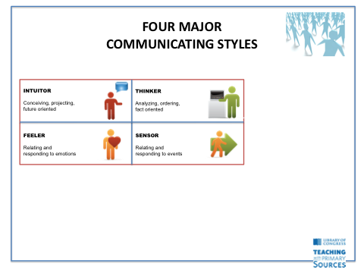

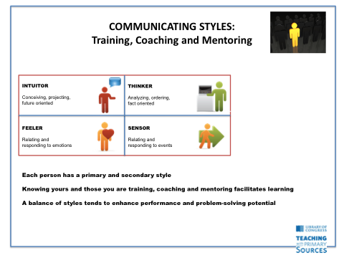

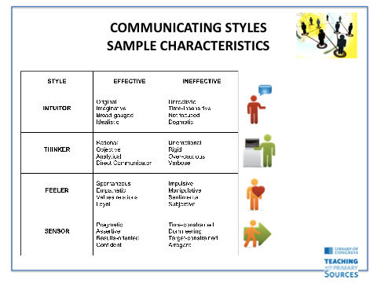
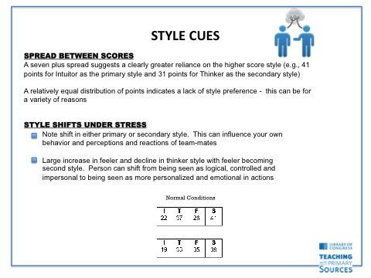
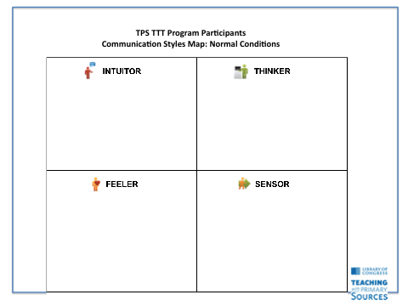

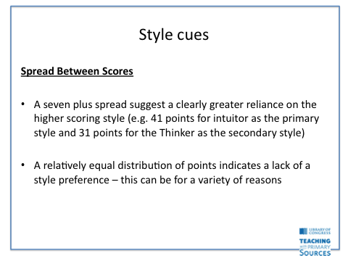

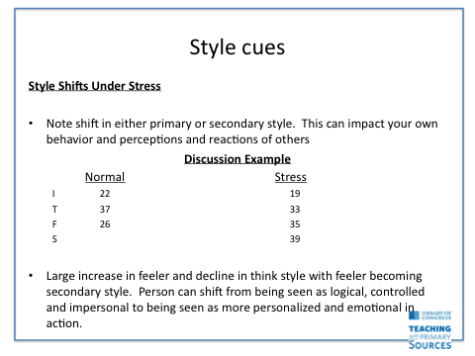

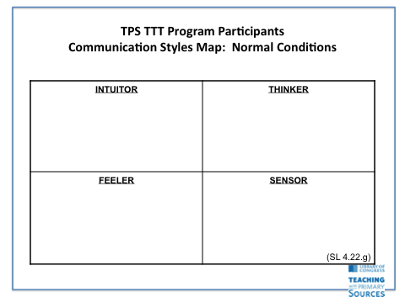

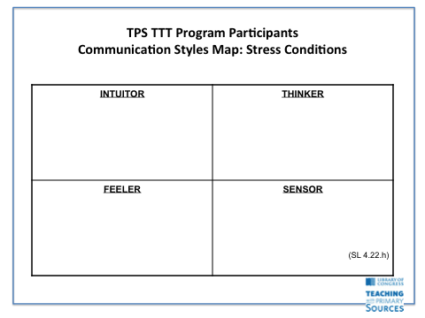

2.6. TPS Program Section Reflection
15 minutes

- ”Takeaway” from TPS Program Section
- Receive feedback on the evaluation results for TPS Program Section
- Ask any open questions remaining from Block Two

Materials

- Summarizing TPS Program Section evaluation results.
- Sufficient copies of handouts to be inserted in each Participant’s Workbook.
- Flip chart easels
- Flip chart pads
- Slide projector
- Flip charts from TPS Program Section (Experience, Resources, Guide Lines, etc.)

Preparation

- Review, summarize and analyze the responses to the TPS Program Section evaluation questionnaire
- Prepare summary slides to present evaluation results to the group

Procedures

- Welcome the participants back to classroom work.
- Ask each participant to write down their one major “learning’ or takeaway from the TPS Program Section.
- Have participants report out “Major learning/takeaways” and record answers on flip chart.
- After all have reported out, comment on similarities/differences in participant responses.
- Ask for reactions and comments from the participants.
- Put the Major Learning/Takeways flip chart up on wall with other flip chart pages.



