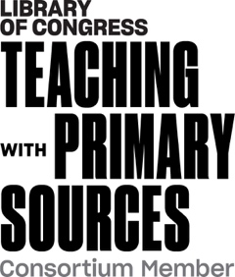
Teaching with Primary Sources Midwest Region
Sub-recipient Reporting
<Project Title>
<Grantee Institution>
<Name of Project Director>

Final Project Report
(due 30 days after project completion)

Please use this outline to describe the activities, audiences, partners, and products related to the overall implementation of this TPS grant-funded project. Plans for sustaining the project beyond the funding cycle should be included.

Brief Overview of Strategy Implementation
Related to the overall timeline as described in the project application
Experiences and Activities
- Description of educators reached (e.g., grade level, subjects, etc.)
- Complete list of Congressional districts reached (Please use the Congressional Districts Map and the nine-digit ZIP codes for schools where participants are employed.)
- Implementation experiences (successes and challenges)
- Reflections on experiences
  - Impact on teaching practice
  - Impact on student learning
Lessons Learned
- Factors associated with:
- Successful/unsuccessful adoption or use of TPS in the classroom
- Specific student populations
- Specific content areas/classroom formats/teaching techniques
- Technology integration
- Intended revisions
- Support received/needed from TPS Midwest Region
- Recommendations for national TPS program
Future Plans
Sustaining the project beyond the funding cycle
Final Payment Request
- Date/projected date submitted
- Amount requested
- Remaining balance (amount to be forfeited)

